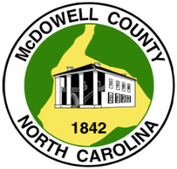
DEPARTMENT OF TAX ADMINISTRATION

TAX CERTIFICATION REQUEST

Date

Parcel ID

Physical Address

Grantor Name

NOTE: Tax Certification will be faxed or emailed to requestor and must be submitted to the Register of Deeds Office to be recorded as last page of deed.

Requestor Name/Firm:

Contact Information:

Phone Number
Fax Number
Email Address

Please submit this request either by fax to 828-652-8401 or email to: taxcertifications@mcdowellgov.com
60 East Court St. Marion, NC ▪ Phone 828-652-7121 ▪ Fax 828-652-8401 ▪ mcdowellgov.com

